Chapter 8, Problem 71.

Obtain v(t) for 0 < t < 4 s in the circuit of Fig. 8.116 using PSpice.
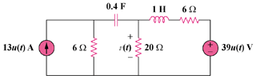

Figure 8.116
For Prob. 8.71.

